Lab 12: Algorithms with AI Assistance – Sorting, Searching,
and Optimizing Algorithms

Name: T. Anjali
Roll no: 2503A52410
Batch: 14

Task Description #1 (Sorting – Merge Sort Implementation)
Prompt: Use AI to generate a Python program that implements
the Merge Sort algorithm.
Input:

def merge_sort(arr):
"""
Sort a list in ascending order using Merge Sort.

Time Complexity: O(n log n)
Space Complexity: O(n)

Args:
arr: A list of elements to be sorted.

Returns:
A new sorted list in ascending order.
"""
if len(arr) <= 1:
return arr.copy()

mid = len(arr) // 2

left = merge_sort(arr[:mid])
right = merge_sort(arr[mid:])

return merge(left, right)

def merge(left, right):
"""Merge two sorted lists into one sorted list."""
result = []
i = 0
j = 0

while i < len(left) and j < len(right):
if left[i] <= right[j]:
result.append(left[i])
i += 1
else:
result.append(right[j])
j += 1

result.extend(left[i:])
result.extend(right[j:])

return result

# Test cases
numbers = [38, 27, 43, 3, 9, 82, 10]

print("Original list:", numbers)
print("Sorted list:", merge_sort(numbers))

print("Test 2:", merge_sort([5, 2, 8, 1]))
print("Test 3:", merge_sort([4, 4, 2, 2]))
print("Test 4:", merge_sort([]))
print("Test 5:", merge_sort([7]))

Explanation:
Merge Sort is a sorting algorithm that arranges elements in ascending or descending order. It uses the Divide and Conquer technique, which means dividing a problem into smaller parts, solving them, and combining the results.

Output:
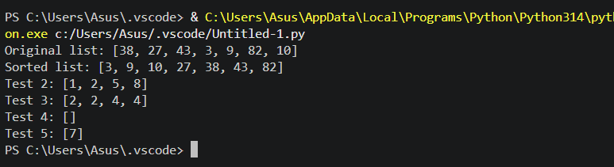

Task Description #2 (Searching – Binary Search with AI
Optimization)
Prompt: Use AI to create a binary search function that finds a
target element in a sorted list.
Input:

def binary_search(arr, target):
"""
Search for a target element in a sorted list.

Args:
arr: A list sorted in ascending order.
target: The element to search for.

Returns:
The index of the target if found, otherwise -1.

Time Complexity:
Best case: O(1)
Average case: O(log n)
Worst case: O(log n)

Space Complexity: O(1)
"""
low = 0
high = len(arr) - 1

# Continue searching while the range is valid
while low <= high:
# Find the middle index
mid = (low + high) // 2

# Check whether the middle element is the target
if arr[mid] == target:
return mid

# Search the right half if target is greater
elif arr[mid] < target:
low = mid + 1

# Search the left half if target is smaller
else:
high = mid - 1

# Return -1 if the target is not found
return -1

# Test cases
numbers = [10, 20, 30, 40, 50, 60, 70]

print("List:", numbers)
print("Search 40:", binary_search(numbers, 40))
print("Search 10:", binary_search(numbers, 10))
print("Search 70:", binary_search(numbers, 70))
print("Search 25:", binary_search(numbers, 25))
print("Search in empty list:", binary_search([], 10))

Explanation:
Binary Search finds a target element in a sorted list by repeatedly dividing the search range into two halves, returning its index if found or -1 otherwise.
Output:
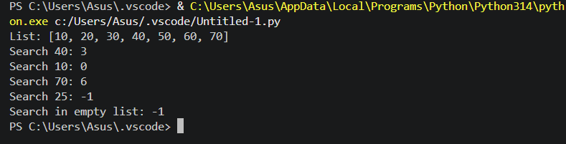
Task Description #3 (Real-Time Application – Inventory
Management System)
• Scenario: A retail store’s inventory system contains
thousands of products, each with attributes like product ID,
name, price, and stock quantity. Store staff need to:
1. Quickly search for a product by ID or name.
2. Sort products by price or quantity for stock analysis.
Prompt:
o Use AI to suggest the most efficient search and sort
algorithms for this use case.
o Implement the recommended algorithms in Python.
o Justify the choice based on dataset size, update
frequency, and performance requirements.
Input:

# Inventory Management System

inventory = [
{"id": 101, "name": "Laptop", "price": 55000, "quantity": 10},
{"id": 102, "name": "Mouse", "price": 500, "quantity": 50},
{"id": 103, "name": "Keyboard", "price": 1200, "quantity": 30},
{"id": 104, "name": "Monitor", "price": 12000, "quantity": 15},
{"id": 105, "name": "Headphones", "price": 2000, "quantity": 25}
]

# Create a dictionary for fast product ID searching
product_index = {product["id"]: product for product in inventory}

def search_by_id(product_id):
"""Search by ID. Average time complexity: O(1)."""
return product_index.get(product_id, "Product not found")

def search_by_name(name):
"""Search by name. Time complexity: O(n)."""
for product in inventory:
if product["name"].lower() == name.lower():
return product
return "Product not found"

def merge_sort(products, key):
"""
Sort products in ascending order using Merge Sort.
Time complexity: O(n log n).
Auxiliary space complexity: O(n).
"""
if len(products) <= 1:
return products.copy()

mid = len(products) // 2
left = merge_sort(products[:mid], key)
right = merge_sort(products[mid:], key)

return merge(left, right, key)

def merge(left, right, key):
"""Merge two sorted product lists."""
result = []
i = j = 0

while i < len(left) and j < len(right):
if left[i][key] <= right[j][key]:
result.append(left[i])
i += 1
else:
result.append(right[j])
j += 1

result.extend(left[i:])
result.extend(right[j:])
return result

def display(products):
"""Display product details."""
for product in products:
print(product)

# Search operations
print("Search by ID:")
print(search_by_id(103))

print("\nSearch by Name:")
print(search_by_name("Laptop"))

# Sorting operations
print("\nProducts sorted by price:")
display(merge_sort(inventory, "price"))

print("\nProducts sorted by stock quantity:")
display(merge_sort(inventory, "quantity"))

Explanation:
The Inventory Management System uses a dictionary for fast product ID searching, linear search for product names, and Merge Sort to arrange products by price or stock quantity efficiently.
Output:
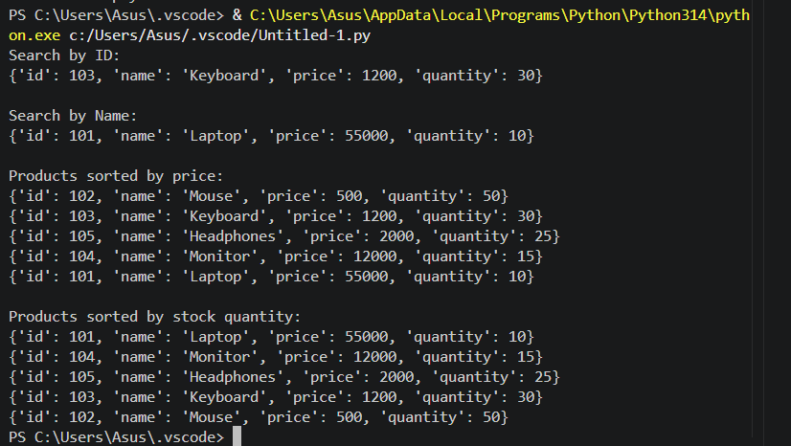

Task description #4: Smart Hospital Patient Management
System
A hospital maintains records of thousands of patients with details
such as patient ID, name, severity level, admission date, and bill
amount. Doctors and staff need to:

1. Quickly search patient records using patient ID or name.
2. Sort patients based on severity level or bill amount for
prioritization and billing.
Student Task
• Use AI to recommend suitable searching and sorting
algorithms.
• Justify the selected algorithms in terms of efficiency and
suitability.
• Implement the recommended algorithms in Python.
Input:

patients = [
{"id": 101, "name": "Ravi", "severity": 2, "admission_date": "2026-10-10", "bill": 15000},
{"id": 102, "name": "Anjali", "severity": 1, "admission_date": "2026-10-11", "bill": 25000},
{"id": 103, "name": "Kiran", "severity": 3, "admission_date": "2026-10-12", "bill": 10000},
{"id": 104, "name": "Priya", "severity": 2, "admission_date": "2026-10-13", "bill": 30000}
]

# Fast patient ID search using a dictionary
patient_index = {p["id"]: p for p in patients}

def search_by_id(patient_id):
return patient_index.get(patient_id, "Patient not found")

# Patient name search using Linear Search
def search_by_name(name):
for patient in patients:
if patient["name"].lower() == name.lower():
return patient
return "Patient not found"

# Merge Sort
def merge_sort(data, key):
if len(data) <= 1:
return data.copy()

mid = len(data) // 2
left = merge_sort(data[:mid], key)
right = merge_sort(data[mid:], key)

return merge(left, right, key)

def merge(left, right, key):
result = []
i = j = 0

while i < len(left) and j < len(right):
if left[i][key] <= right[j][key]:
result.append(left[i])
i += 1
else:
result.append(right[j])
j += 1

result.extend(left[i:])
result.extend(right[j:])
return result

# Display patient records
print("Search by Patient ID:")
print(search_by_id(102))

print("\nSearch by Patient Name:")
print(search_by_name("Ravi"))

print("\nPatients sorted by Severity (highest priority first):")
display_severity = merge_sort(patients, "severity")
display_severity.reverse()
for patient in display_severity:
print(patient)

print("\nPatients sorted by Bill Amount (lowest to highest):")
for patient in merge_sort(patients, "bill"):
print(patient)
Explanation:
The Smart Hospital Patient Management System uses a dictionary for fast patient ID searches, linear search for patient names, and Merge Sort to arrange patients by severity level or bill amount efficiently.
Output:
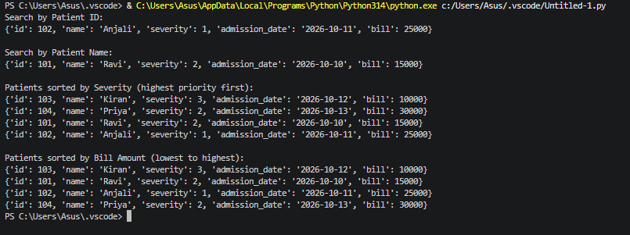

Task Description #5: University Examination Result Processing
System
A university processes examination results for thousands of students
containing roll number, name, subject, and marks. The system must:
1. Search student results using roll number.
2. Sort students based on marks to generate rank lists.
Student Task
• Identify efficient searching and sorting algorithms using AI
assistance.
• Justify the choice of algorithms.
• Implement the algorithms in Python.
Input:

students = [
{"roll_no": 101, "name": "Anjali", "subject": "Python", "marks": 85},
{"roll_no": 102, "name": "Ravi", "subject": "Python", "marks": 92},
{"roll_no": 103, "name": "Priya", "subject": "Python", "marks": 78},
{"roll_no": 104, "name": "Kiran", "subject": "Python", "marks": 95}
]

# Search using Dictionary
student_index = {s["roll_no"]: s for s in students}

def search_student(roll_no):
return student_index.get(roll_no, "Student not found")

# Sort using Merge Sort
def merge_sort(data):
if len(data) <= 1:
return data.copy()

mid = len(data) // 2
left = merge_sort(data[:mid])
right = merge_sort(data[mid:])

return merge(left, right)

def merge(left, right):
result = []
i = j = 0

while i < len(left) and j < len(right):
if left[i]["marks"] >= right[j]["marks"]:
result.append(left[i])
i += 1
else:
result.append(right[j])
j += 1

result.extend(left[i:])
result.extend(right[j:])
return result

print("Search Result:")
print(search_student(102))

print("\nRank List (Highest Marks First):")
rank_list = merge_sort(students)

for rank, student in enumerate(rank_list, start=1):
print(rank, student["roll_no"], student["name"], student["marks"])
Explanation:
The system uses a dictionary for fast roll-number searching and Merge Sort to generate a rank list from highest to lowest marks, with average search time \(O(1)\) and sorting time \(O(n\log n)\).
Output:
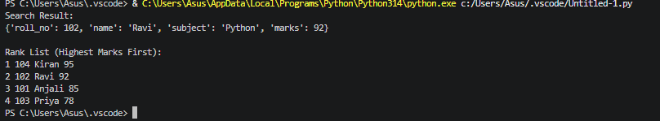
Task Description #6: Online Food Delivery Platform
An online food delivery application stores thousands of orders with
order ID, restaurant name, delivery time, price, and order status. The
platform needs to:
1. Quickly find an order using order ID.
2. Sort orders based on delivery time or price.
Student Task
• Use AI to suggest optimized algorithms.
• Justify the algorithm selection.

• Implement searching and sorting modules in Python.
Input:

orders = [
{"order_id": 101, "restaurant": "Dominos", "delivery_time": 30, "price": 500, "status": "Delivered"},
{"order_id": 102, "restaurant": "Burger King", "delivery_time": 20, "price": 300, "status": "Preparing"},
{"order_id": 103, "restaurant": "Pizza Hut", "delivery_time": 40, "price": 700, "status": "On the way"},
{"order_id": 104, "restaurant": "KFC", "delivery_time": 25, "price": 400, "status": "Delivered"}
]

# Fast search using Dictionary
order_index = {order["order_id"]: order for order in orders}

def search_order(order_id):
return order_index.get(order_id, "Order not found")

# Merge Sort
def merge_sort(data, key):
if len(data) <= 1:
return data.copy()

mid = len(data) // 2
left = merge_sort(data[:mid], key)
right = merge_sort(data[mid:], key)

return merge(left, right, key)

def merge(left, right, key):
result = []
i = j = 0

while i < len(left) and j < len(right):
if left[i][key] <= right[j][key]:
result.append(left[i])
i += 1
else:
result.append(right[j])
j += 1

result.extend(left[i:])
result.extend(right[j:])
return result

# Search an order
print("Search Order:")
print(search_order(102))

# Sort by delivery time
print("\nOrders sorted by delivery time:")
for order in merge_sort(orders, "delivery_time"):
print(order)

# Sort by price
print("\nOrders sorted by price:")
for order in merge_sort(orders, "price"):
print(order)
Explanation:
The system uses a dictionary to find orders quickly by order ID and Merge Sort to arrange orders by delivery time or price.
Output:
